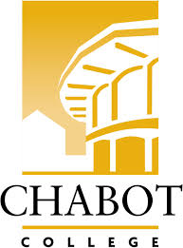
Career Education (CE Committee)
Chabot College – Zoom
Monday, March 24, 2025
12:00-1:00

AGENDA

- Welcome & Land acknowledgement – Terra
- Review and approve minutes of last meeting - Kristina
- Announcements
  - Professionals in the Legal Field Workshop – Robin
  - CE one-page overview and other marketing tools
  - CE Events (on campus)
    - Paving a Path for the Future, Mental and Behavioral Health Workforce, Bay Area Regional Convening - 3/25
    - SOAR Day – 4/19
    - ECD Job Fair – 4/29
    - ROP Digital Media Day – 5/2
    - Ambulance Meet & Greet Day – 5/23
- Career Education Open House reflection and feedback
- CE Website – Robin
  - Website discussion recap (5 min)
  - Breakout groups/discussion (15 min)
  - Breakout group reports (5 min)
- Good of the Order - Kristina
- Next Meeting 4/14/2025
- Adjournment

Mission Statement
Chabot College is a dynamic, student-centered community college that serves the educational, career, job skill, and personal development needs of our community. We provide culturally responsive, revitalizing, and sustaining learning and support services driven by a goal of equity. Building upon students’ strengths and voices, we empower students to achieve their goals and lead us towards an equitable and sustainable world.

